**4B OS LAB-10 ASSIGNMENT | MUHAMMAD DANISH | CS182019**

**CODE SCREENSHOTS**

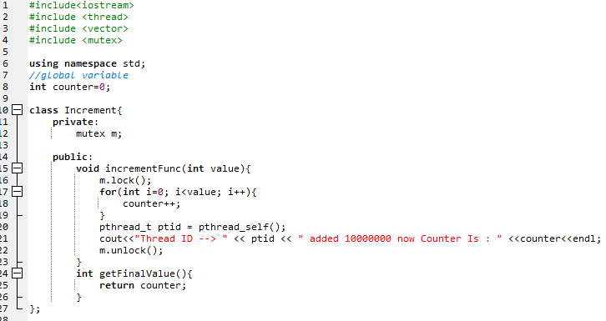

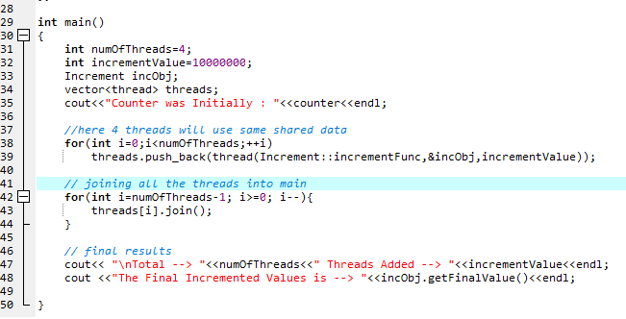

**CODE OUTPUTS**

**Race condition (without Mutex)**

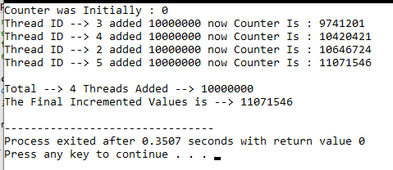

**Race condition solved with Mutex**

